**Simulation Technology for Healthcare Training**

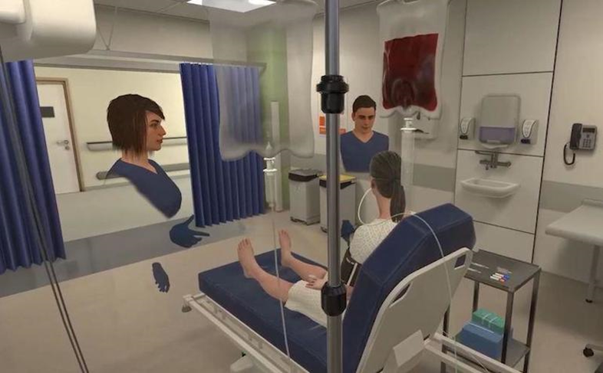

Pre Covid-19 Tracheostomy training was delivered through a combination of online education and face-to-face simulation training; however, the latter has become increasingly difficult in the current climate due to the challenges of social distancing, lack of training facilities and the need for self-isolation. As a result, NHS staff have had reduced access to this necessary training which is needed to maintain their clinical competencies and to ensure the best care of patients with tracheostomies.

The problem is currently occurring in every Health Board within NHS Wales and across the UK. Even prior to the challenges described above, access to training has been variable and of differing standards. Previously training has been delivered on a 1:1 basis using very low fidelity simulation involving a basic mannequin, which has no resemblance to the clinical environment.

We have attempted to deliver simulation training via online platforms but with very limited success due to the challenges of interacting and the inability to get ‘hands-on’ experience. As such this has now ceased as it was deemed not effective and the need for future fit training has been recognised that takes advantage of emerging digital and technology advancements.

Whilst the first phase of this challenge would initially be focused on Tracheostomy training there is potential for the application of the innovation to be used in many other areas, including basic, intermediate, and advanced life support. Furthermore, the technology could be used for specific simulation training across all specialities across all Health Boards.

This challenge is reacting to an unprecedented global pandemic. A rapid Phase 1 SBRI will identify solutions for further development. Subsequent activity will support selected solutions through next phases and explore the potential to expand the scope of the challenge to other areas of training need across the NHS.

We are looking to identify and demonstrate rapid simulation technology solutions in an operational environment, solutions must be suitable for rapid deployment and for successful solutions we envisage full accreditation to be in place ready for ‘real world’ deployment by no later than October 2021.

As an example of the way in which the use of simulation training could be expanded following the competition, the Critical Care team has identified common procedures and scenarios they would prioritise once this capability is available to them.

A successful outcome would:

* Deliver Tracheostomy training in an appropriate safe way.
* Make the training experience as close as possible to the bedside experience, providing a real sense of the actual environment.
* Reduce the need for face-to-face training.
* Deliver training in a more convenient method, without time or location restrictions, increasing numbers being trained and reducing any backlogs.
* Enable consistency of training provided across all Health Boards, including the recording, review and analysis of training procedures
* Enable the clinician to maintain clinical competencies and any revalidation requirements.
* Have a wider applicability to address similar issues in other specialities.
* Ensure patient safety was maintained through providing relevant training to clinicians.
* Generate opportunities for local businesses (e.g. creative industry sector)
* Support place based economic development and local wealth building in the CCR
* Result in innovative new products and services which have a pathway to rapid scaling commercially beyond local markets

Innovations must be suitable for **rapid** deployment in Tracheostomy Training for Phase 1 and any solution must have wider applicability to other clinical settings.

We need ideas that can be rapidly developed and tested with potential to be scaled and used across Wales and beyond over the coming months.

In total, up to £400k funding is available for this challenge. The Challenge is structured across three phases with key dates listed below:

**Phase 1**: Feasibility – We are looking to fund up to 5 projects up to a value of £30,000 each for Phase 1.

Note: Only projects successful at phase 1 will be eligible to apply to phases 2 and 3

**Phase 2**: Development - We expect to fund up to 2 of the most successful phase 1 projects for use in Tracheostomy training within Cardiff and Vale Health Board, in addition to develop agreed additional training packages outside of Tracheostomy.

**Phase 3**: Testing – This Phase will be to robustly test up to 2 of the successful Phase 2 solutions within Cardiff and Vale Health Board in real life operating conditions making final technical improvements. To provide assurance and validation to other Health Boards across Wales who may wish to adopt the solution post SBRI. **Please note** any adoption and implementation of a solution from this competition would be subject of a separate, possible competitive, procurement exercise. This competition does not cover the purchase of any solution although we may choose to investigate and explore innovative procurement routes as part of this challenge.

The total funding available for the competition can change. The funders have the right to:

* adjust the provisional funding allocations between the phases
* apply a ‘portfolio’ approach

|  |  |
| --- | --- |
| Phase 1 Activity | Key Dates **subject to change ** |
| Open Date – Phase 1 | 26th April 2021 |
| Briefing event | 13th May 2021 |
| Close Date | 28th May 2021 |
| Meet and Greet with Suppliers | 9th June 2021 |
| Applicants notified | 10th June 2021 |
| Phase 1 contracts awarded | 14th June 2021 |
| Feedback | 24th June 2021 |
| Projects Commence | 21st June 2021 |
| Projects Complete - | 06th August 2021 |
| Phase 2 Activity | Key Dates **subject to change ** |
| Phase 2 applications to be reviewed and decision on company/companies to take forward | 11th August 2021 |
| Feedback to unsuccessful P2 applicants | 11th August 2021 |
| Phase 2 contacts signed and commencement of Phase 2 | 17th August 2021 |
| Phase 2 project closure | 1st October 2021 |

|  |  |
| --- | --- |
| Phase 3 Activity | Key Dates **subject to change ** |
| Phase 3 applications to be reviewed and decision on adopt launch | 8th October 2021 |
| Adoption of solution to commence | Mid October onwards |

**Briefing Event**

Please follow the link below and register your interest for the virtual Briefing Event held on 13 May 2021.

Link: [Business Wales Events Finder - Welsh Government, W, Event organisers (business-events.org.uk)](https://wales.business-events.org.uk/en/event-organisers/w/welsh-government/)

**FURTHER INFORMATION**

For more information on this competition, visit: [https://sdi.click/simtech](https://scanmail.trustwave.com/?c=261&d=-uuG4FWW96D9FN483gIYmwv_iAJBD8gLJ3Zr1yGcww&u=https%3a%2f%2fsdi%2eclick%2fsimtech)

For any enquiries about this competition e-mail: [SBRI.COE@wales.nhs.uk](mailto:SBRI.COE@wales.nhs.uk)