**Outpatient Transformation – Challenge brief**

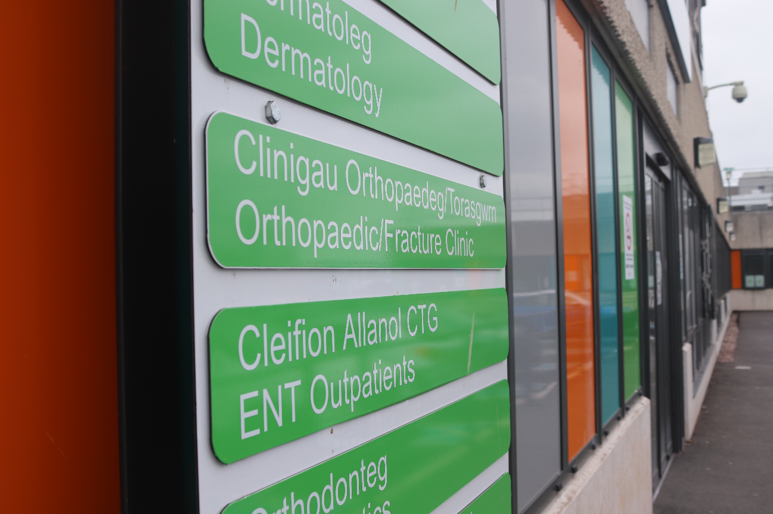

The way outpatient services are being delivered in Wales is undergoing a period of Transformation to ensure that it delivers the care for patients in a prudent and value-based way for a sustainable health-care model for the future.

COVID has led to a significant backlog in review of referrals in secondary care and as capacity is not going to match demand, innovative ways of managing patients differently to reduce unnecessary referrals are eagerly sought.

COVID has also provided a trigger for a more rapid adoption of the change process leading to the use of more digital solutions such as virtual working and contacts with patients made electronically. There is the need to ensure the correct patients access secondary care services with an emphasis to support more activity in the primary care and community setting, as well as a more self-directed model of care.

Clinically this has been recognised as the future model of care and is a core component of the national strategy for future health as described in our core Welsh Health policy: ‘A Healthier Wales’.

To support this transition to more primary and community care as well as digitally supported models of care we seek for innovations to support three key areas in our strategy:

***Theme 1: Management of conditions that require multiple tests for either a decision to refer/treat or as part of a disease surveillance pathway.***

There are many specialties and conditions that often require repeat tests, which may be blood tests, x-rays, or other investigations and a solution to facilitate this workflow, will add a layer of safety and efficiency.

The innovation we seek, is to streamline this process to develop through integration with our results reporting system an automated way of checking result of tests, automatically issuing a repeat test for the patient which could be a blood test or other investigation, sending this out with information (as agreed clinically) to the patient on the need for a repeat/further test and where to go to have the blood test undertaken. This could be combined with a patient questionnaire particularly with chronic disease surveillance. Finally, once the test is performed and both the results are available, these results (+/- questionnaire) are then forwarded through electronic correspondence to the GP or secondary care clinician in a short report.

This solution it is hoped. will pave the way to automation of many other ‘repeat’ investigations as part of a patient diagnosis and self-management service. Patients often need repeat tests for diagnostic purposes or need repeat tests as part of a surveillance pathway as supported by their clinical teams.

The innovation may also look to combine the automated process for prompting and arranging tests/questionnaires to patients by producing a simple web/phone ‘app’. Some specialties may use the questionnaire as the ‘test’ perhaps as part of an annual review and not need any other specific investigation (blood test or x-ray etc.)

Examples where such a beneficial solution for an assisted, automated & integrated workflow, includes:

1. *Urology*

Male patients who visit their GP with urinary symptoms have a blood test to look for disease of the prostate (the blood test is called Prostate Specific Antigen – PSA), and when elevated often requires a second blood test to be arranged to confirm the finding. This currently requires human intervention – checking the blood result, completing another blood form and arranging for the test to be carried out. This second test then needs to be chased up before finally reviewing the results and deciding if both tests are abnormal that a referral into secondary care should be made.

1. *Diabetes and monitoring of HbA1c*

To monitor for adequate control of diabetes, patients undergo a blood test to measure HbA1c (glycosolated haemoglobin). This is either done as part of diagnostics, routine surveillance or when there is a change in diabetic treatment. Supporting patients in their surveillance pathway with reminders and automated test requests would ensure all patients undergo the recommended monitoring of treatment. This could be combined with a patient questionnaire.

1. *Thyroid disease and monitoring of Thyroid function tests*

Similar to diabetes, thyroid function tests are performed when patients with thyroid disease either have an adjustment to medication or as part of a regular monitoring of adequacy of treatment.

1. *Monitoring liver function when on certain medication or as part of the Liver disease pathway*

Monitoring liver disease when on certain drugs known to cause liver damage is essential as well as patients liver cirrhosis for primary liver cancer (blood test and ultrasound). Integrating these tests in an intelligent way through adoption of an automated surveillance system would ensure any deterioration is identified promptly. Drugs used in rheumatoid arthritis in particular need such monitoring. The solution may also look to integrate a questionnaire as part of the request for blood testing (and/or ultrasounds testing) to facilitate the patient management workflow and form part of the report back to the responsible clinician.

1. *Repeat lung function tests after initiation of treatment or surveillance of chronic respiratory disease*
2. *Annual echocardiography for patients with valvular heart disease and monitoring of NT-pro BNP in heart failure*

Similar to liver disease, many heart conditions need annual and sometimes more frequent surveillance through repeat echocardiography. The solution would look to prompt patients and provide the necessary form and instructions to undertake the test and similarly may also include a questionnaire to facilitate the clinician workflow when the results are sent back with the report.

1. *Repeat x-rays for rheumatological and musculoskeletal disease*

The repeat radiology could again be combined with a patient questionnaire to facilitate clinician decision making and workflow.

1. *Repeat blood tests for surveillance of certain cancers to identify early recurrence*

A combination again of tests and a questionnaire would be helpful to the clinician workflow to identify those patients who need further review.

***Theme 2: Patient-clinician digital communication***

The second solution we are looking for an innovation is to improve communication by patients with their clinical teams. One pathway we are promoting is the use of ‘See on symptoms’. This pathway provides the patient with information on how to look out for return of symptoms for which they have received treatment. The solution would look to provide a digitally enabled communication gateway to connect with their clinical teams in either a synchronous or an asynchronous way in an agile and responsive way.

We are aware there are many solutions available to support patient self-management, however the solution we are seeking is a specific element of self-management focussing on enhanced communication by patients back into the service.

The key component of such a solution is to provide an asynchronous platform for two-way communication between patients and their clinical teams and avoid the need to use a telephone. Such a digital solution will inherently improve governance through having the facility to upload the digital communication onto the electronic patient record and monitor activity, to support agile learning and improvements in patient flow management.

***Theme 3: Review of images/samples***

The third innovation we are seeking a solution is to utilise emerging high-power computing power and machine learning technologies as part of the wider advances in artificial intelligent (AI) to analyse photographs or other patient samples.

One example is the analysis of photographs of dermatology lesions.

We have a significant number of referrals into secondary care with lesions both suspicious of cancer and others that are considered benign and due to significant reduction in capacity across Wales in dermatology clinicians, there is significant delay in these being reviewed.

Recognition of significant advances in diagnostics of cytology samples in tissue types such as cervix and breast we look to find a robust, validated, clinically assured AI solution to rapid diagnostics from skin lesion dermatograph images.

This solution looks to ensure these patient lesions are reviewed and diagnosed accurately with robust governance structures, recognising such a solution may have a degree of uncertainty in some samples/images and these might need formal review by a human clinician. A large proportion it is hoped, will be successfully reviewed with a diagnosis with high degree of sensitivity and specificity.

Dermatology is used here as an example, but there are opportunities for advancements in use of AI technologies for high-volume processing of large numbers of patients samples/images for multiple specialties and conditions.

The Challenge is structured across two phases with key dates listed below:

**Phase 1** Feasibility & Demonstrator - Organisations can apply for a share of up to £400,000 to deliver feasibility and/or demonstrator projects that can address the proposed challenge. We are looking to fund up to six projects and these projects can range in size up to total costs of £400,000, inclusive of VAT, to be delivered over a 3 month duration, dependent on scale and readiness of solutions.

**Phase 2**: Development & Testing- The most promising Phase 1 projects may have the opportunity to access additional funding to undertake further development and robust testing. Successful applicants can apply for a share of £400,000 inclusive of VAT (subject to budget availability), with the intention to take forward up to three projects to provide assurance and validation to other Health Boards across Wales who may wish to adopt the solution post SBRI.

The total funding available for the competition can change. The funders have the right to:

* adjust the provisional funding allocations between the Phases
* apply a ‘portfolio’ approach
* fund the best projects regardless of the theme (this may mean we do not fund a project for every theme)

|  |  |
| --- | --- |
| Phase 1 Activity | Key Dates **subject to change ** |
| Open Date – Phase 1 | 19th April 2021 |
| Briefing event | 29th April 2021 |
| Close Date | 14th May 2021 |
| Meet and Greet with Suppliers | 24th May 2021 |
| Applicants notified | 14th June 2021 |
| Phase 1 contracts awarded | 14th June 2021 |
| Feedback | 30th June 2021 |
| Projects Commence | 21st June 2021 |
| Projects Complete | 27th August 2021 |
| Phase 2 Activity | Key Dates **subject to change ** |
| Phase 2 applications to be reviewed and decision on adopt launch | 31st August 2021 |
| Adoption of solution to commence | 6th September 2021 |
| Phase 2 project closure | Dependant on solutions 3-12 months after P2 commences |

**Briefing Event**

Please follow the link below and register your interest for the virtual Briefing Event held on 29th April 2021.

Link: <https://wales.business-events.org.uk/en/event-organisers/w/welsh-government/>

**FURTHER INFORMATION**

For more information on this competition, visit: [https://sdi.click/outpatients](https://scanmail.trustwave.com/?c=261&d=n-_34DoZXgMPMHfdMmgZ-XUgfXJXUXKS3-a6jqGKMg&u=https%3a%2f%2fsdi%2eclick%2foutpatients)

For any enquiries about this competition e-mail: [SBRI.COE@wales.nhs.uk](mailto:SBRI.COE@wales.nhs.uk)