**How can we supply clinical staff with more appropriately fitting, safe and economical respiratory protection and ensure delivery of an assured fit in a more efficient manner?**

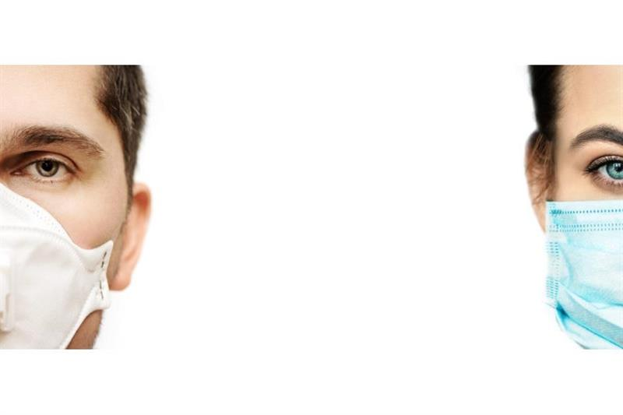

Dental Services have had to accommodate huge changes in the way that they operate as a result of COVID-19 additional infection control precautions.

Aerosols are generated during a number of dental procedures such as fillings, scaling, some surgical procedures, increasing the risk of exposure to Covid-19 infection and, potentially, other respiratory pathogens such as TB to dental staff.

The widespread use of enhanced-level PPE or Personal Protective Equipment (defined as level 2 in Wales) which includes use of disposable (single-use) face mask respirators known as FFP3 masks has now become accepted essential practice when providing any aerosol-generating procedure (AGP) in dentistry.

The fit of an FFP3 respirator mask is somewhat bespoke compared to the fit of the traditional type of mask used in dentistry. It is essential to ensure that the respirator mask for each individual is the correct size and design and provides an adequate seal or fit. An inadequate fit increases the potential for exposure to infection.

The design origins of many current commercially available respirators derive from industrial rather than healthcare applications. The full range of facial shapes and sizes is not universally represented or available. The result is that many healthcare staff, especially those with a smaller frame may find it difficult to “fit” to the currently available types, and alternative, more expensive solutions such as PAPR hoods may need to be sourced. In some cases individuals may not even be able to carry out their normal duties, due to lack of availability suitable facial/respiratory PPE.

The process of fit-testing staff to the respirators supplied can also take a substantial amount of staff time away from clinical situations, in particular if the only or limited range of available respirator mask being tried (“fitted”) is not at all of suitable type or size for that individual.

In addition, the cost of disposable respirator-type masks is high, compared to the cost of “traditional” dental facemasks. Facemasks should be changed after every patient procedure.

There are also some concerns around the environmental impact and waste trails.

We are looking to identify, develop and demonstrate disposable respirator facemask and respiratory protection technologies that:

* Can be tailored to fit the full range of face shapes and sizes.
* Comply with the minimum filtration value of current FFP3 respirator masks.
* Demonstrate compliance with FFP3 standards and efficacy (equivalent to CE mark).
* Will have design informed by the practicalities of safe clinical dental treatment provision, and could also be suitable for other clinical specialty usage.
* Could have the potential to integrate new systems and/or improve current practices, thereby improving fit-matching for some existing NHS Wales stocks of FFP3 masks.
* Could comply with currently accepted systems of fit-testing, or for which novel and effective new ways of fit-selection and fit-testing could be developed. For example, the development of an initial “sizing” system which could be used in the clinician’s own workplace and which could “narrow down” the choices to identify a smaller range of masks that may provide a good fit.

In addition to the above additional consideration will be given to those technologies that:

* Are easily recyclable (either fully or partially) to reduce further environmental impact.
* Could be designed to improve patient’s experience, for example for improved communication for those with hearing impairments or learning disability; child-friendly designs.
* Are safe, cost effective and sustainable, with a focus on shorter, UK based supply chains to reduce the risk of supply chain disruptions.
* Could make the current physical tests of seal (for example those using Portacount systems) more efficient, more likely to be a positive experience and more likely to result in a positive outcome.

Innovations must be suitable for **rapid** deployment in NHS dentistry settings. Ideally, systems will have wider applicability throughout other clinical settings.

We need ideas that can be rapidly developed and tested with potential to be scaled and used across the UK over the coming months, key dates are listed below:

|  |  |
| --- | --- |
| Activity | Week commencing |
| Open date | 11th November 2020 |
| Close date | 4th December 2020 |
| Briefing event | 23rd November 2020 |
| Interviews for shortlisted applicants | 14th December 2020 |
| Applicants notified | 18th December 2020 |
| Phase 1 contracts awarded | 6th January 2021 |
| Feedback | 6th January 2021 |
| Projects Commence | 11th January 2021 |
| Projects Complete | 31st March 2021 |

*** Please note dates are subject to change **

We expect to fund up to 5 projects, with contracts anticipated to be up to £50,000+VAT each.

**Briefing Event**

Please follow the link below and register your interest for the virtual Briefing Event held on 23rd November 2020 at 10am-11am:

[https://wales.business-events.org.uk/en/events/sbri-face-mask-challenge/](https://scanmail.trustwave.com/?c=261&d=hJiq3-WOabYZTc1tcQzMN0pxGOi6SBDrz52U59fnHg&u=https%3a%2f%2fwales%2ebusiness-events%2eorg%2euk%2fen%2fevents%2fsbri-face-mask-challenge%2f)

**FURTHER INFORMATION**

For more information on this competition, visit: [sdi.click/facemasks](https://scanmail.trustwave.com/?c=261&d=7--q33_mXk4hvHzZvAPPPmhEpQkM272nEAdXNkg4hw&u=https%3a%2f%2fsdi%2eclick%2ffacemasks)

For any enquiries about this competition e-mail: [SBRI.COE@wales.nhs.uk](mailto:SBRI.COE@wales.nhs.uk)