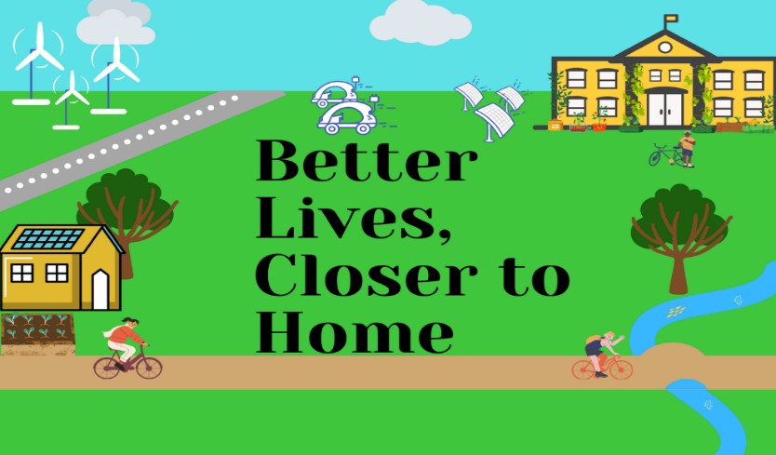

**Better Lives Closer to Home   
Supporting our communities, businesses and public sector during the pandemic and beyond**

**What are Small Business Research Initiatives (SBRIs)?**

SBRIs enable the public sector to connect with innovative ideas from businesses, providing new solutions to specific challenges.

They help public bodies engage with organisations from different sectors and small and emerging businesses. New technical solutions can be demonstrated through accelerated technology development, whilst risk is reduced through a phased development and a transparent, competitive, reliable source of early-stage funding.

Competitions are open to all organisations that can demonstrate a route to market. SBRIs are particularly well-suited to small and medium-sized businesses because they operate under pre-commercial procurement contracts and on fixed timescales. Projects are 100% funded and focus on specific identified needs, increasing the chance of exploitation. Suppliers are selected by open competition and organisations retain the intellectual property generated from the project, with certain rights of use made available to the contracting authorities.

**Scope**

The COVID-19 outbreak has deeply affected communities, society and individuals, whether the effects are on physical or mental health, economic impact, loss of jobs and income, living standards and the increased pressure on medical and social services.

To aid a recovery, Welsh Government and the SBRI Centre of Excellence will fund organisations to develop new products or services that will support our long term health and wellbeing with a focus on better lives closer to home. Your solution must help communities, businesses or the public sector adapt to the ongoing threats of COVID-19 and progress priorities contained in the Welsh Government [Prosperity for All: Economic Action Plan](https://gov.wales/sites/default/files/publications/2019-02/prosperity-for-all-economic-action-plan-executive-summary.pdf)

Applications are invited to deliver rapid feasibility study research and development (R&D) projects, with funding available up to £50,000, including VAT. With an envelope of £250k, we expect to fund up to 5 projects in total (or more if budget permits) and the successful projects must commence delivery in January 2021 and complete by end of March 2021.

**Better Lives, Closer to Home**

The Welsh Government wants to identify and support projects that will support better lives closer to home and align with the following key themes:

* **Build Back Green** - enabling businesses and communities to adapt to the ongoing challenges posed by COVID-19 with a focus on a healthier, cleaner and more sustainable Wales. We are looking for solutions that enable people to continue to work closer to home, considering accessibility and safety whilst maintaining a sense of community and connection. Examples might be enabling communities to support a circular economy, reducing waste or increasing the efficient use of existing resources, or alternative uses for buildings, or addressing high levels of traffic or industrial emissions.
* **Sustainability and security of supply chains** - Supporting place-based and needs-led business supply chains that secure jobs and safeguard against further supply chain disruptions so that our communities have access to healthy food or decrease food poverty, especially those exploring low-carbon or carbon-neutral methods with a focus on affordability and continuity of supply. This may include innovative growing methods, reducing/repurposing of waste and logistics
* **Supporting mental and physical wellbeing for all generations -** new products and services addressing mental health, access to care, or the resilience of communities. Projects might tackle greater access to resources in the community which support greater wellbeing, or increase the accessibility of active travel; solutions that may reduce the impact of winter confinement on individuals’ physical and mental wellbeing. Others might increase access to cultural experiences, supporting the creative industries so severely impacted by COVID-19, and ensuring our communities continue to value the arts, culture and natural environment that Wales is so well-known for

The key focus will be on demonstrating feasibility, affordability and scalability of solutions that can be delivered at pace. We are looking to test new and emerging innovations via small-scale trials, creating an evidence base for further development and scale, considering affordability and practicality.

To lead a project, you can be an organisation of any size but must be able to work in Wales/with Welsh lead customers under prevailing Covid restrictions at the time of award. Academic institutions and registered charities can apply but must demonstrate a route to market, including a plan to commercialise the results.

Contracts will be awarded to individual organisations but you can sub-contract specific tasks that benefit the overall project. Ideally, subcontractors will have particular insight into the identified challenge area or clean growth agenda or be sector specialists or relevant academic institutions. Any subcontracted work is the responsibility of the main contractor.

Your organisation must work with identified potential future customers, throughout Phases 1 and 2. The potential customer can be a public sector organisation looking to tackle such a challenge but they must be based in Wales. Challenge applications should detail how you will work together to understand requirements and explore the feasibility of your proposal.

**How can solutions address the challenges?**

Innovative solutions could: -

* Accelerate the adoption of emerging digital and smart technology to support the mental wellbeing of people within their communities;
* Accelerate decarbonisation, reducing the impact of emissions on health;
* Increase access and security of vital products and services, especially to affordable and sustainable food, tackling the impacts of food poverty;
* Support quality jobs closer to home, reducing unemployment or the need to commute;
* Develop a place-based solution, showing an awareness of existing strengths within communities and outlining how the project will build on those strengths;
* Encourage long term behavioural change, enabling people to play an active role in their own wellbeing

**Out of Scope**

We are not looking to fund projects which:

* Do not meet the requirements outlined in the scope
* Do not engage with potential future customers to understand needs
* Cannot be undertaken within the working restrictions of COVID-19
* Do not address how any potentially negative outcomes would be managed
* Do not evidence how a proposal will generate positive economic or societal impact
* Duplicates existing innovation, or work in progress by others

**Policy Context**

The ‘**Wellbeing for Future Generations Act (2015)’** aims to improve the social, economic, environmental and cultural well-being of Wales. The Act sets out seven goals which represent the long term vision for Wales. Public bodies now need to think more about the long-term, work better with people and communities and each other, look to prevent problems and take a more joined-up approach. Public bodies must operate in a way that ensures that the needs of the present are met without compromising the ability of future generations to meet their own needs. Public bodies are required to ensure that when making decisions they take into account the impact they could have on people living their lives in Wales in the future.

**Funding Allocation & Project Details**

The purpose of this challenge is to deliver a Phase 1 -Technical Feasibility study. There is then potential to proceed to Phase 2 - Prototype Development and Evaluation, depending on the outcomes from Phase 1.

**Phase 1: technical feasibility -** This study should result in a technical and commercial specification and detailed design package for a digital solution.

The first phase involves feasibility study research and development (R&D) contracts being awarded up to £50,000, including VAT. Due to the range of themes outlined in the brief, assessments will be made on a portfolio approach.

**Phase 2: prototype development and evaluation –** This should result in a limited production demonstrator or pilot programme to be tested in conjunction with an end user(s). The 2 projects from Phase 1 assessed to have the greatest impact will have the opportunity to access Phase 2 funding up to £200,000, subject to budget availability from Welsh Government.

Other Public sector challenge fund competitions are due to commence within South East region of Wales from other funders. Consideration will be made if these competitive funding options are alternative or more appropriate to your project and we can provide further details.

Your application must:

* demonstrate a clear plan for commercialisation and a route to market for affordable, developed solutions;
* set out clearly how solutions might be tested in a representative or real world setting as part of phase 2;
* explain the potential positive contribution to the goals of Wellbeing of Future Generations (Wales) Act;
* consider, and address where necessary, equality, diversity and inclusion aspects across your project, your sector(s) and society;
* address how any potentially negative outcomes would be managed
* work throughout with at least one potential future customer who might use your solution when it comes to market

**Application Process**

Directions on how to enter this competition can be found via [sdi.click/betterlives](http://scanmail.trustwave.com/?c=261&d=27Ka39KYDqIUx9daD7GfTxNYd1llCJnZVJL9x46tEw&u=http%3a%2f%2fsdi%2eclick%2fbetterlives)

**KEY DATES**

|  |  |
| --- | --- |
| Open date | 4th November 2020 |
| Close date | 27th November 2020 |
| Briefing event | 12th November 2020 |
| Meet and Greet with Suppliers’ | 7th December 2020 |
| Decision Release | 11th December 2020 |
| Phase 1 contracts awarded | 11th December 2020 |
| Feedback | 14th December 2020 |
| Projects Commence | 4th January 2021 |
| Projects Complete | 31th March 2021 |

*All dates may be subject to change

**Briefing Event**

Please follow the link below and register your interest for the virtual Briefing Event held on 12th November 2020 at 10am-11am:

[https://wales.business-events.org.uk/en/events/sbri-better-lives-closer-to-home/](https://scanmail.trustwave.com/?c=261&d=k_yb34LO-jhLDTb_dsn8ggfhK3HCz9L9ovw8LpWr7w&u=https%3a%2f%2fwales%2ebusiness-events%2eorg%2euk%2fen%2fevents%2fsbri-better-lives-closer-to-home%2f)

**FURTHER INFORMATION**

For more information on this competition, visit:

[sdi.click/betterlives](http://scanmail.trustwave.com/?c=261&d=27Ka39KYDqIUx9daD7GfTxNYd1llCJnZVJL9x46tEw&u=http%3a%2f%2fsdi%2eclick%2fbetterlives)

For any enquiries about this competition e-mail: [SBRI.COE@wales.nhs.uk](mailto:SBRI.COE@wales.nhs.uk)